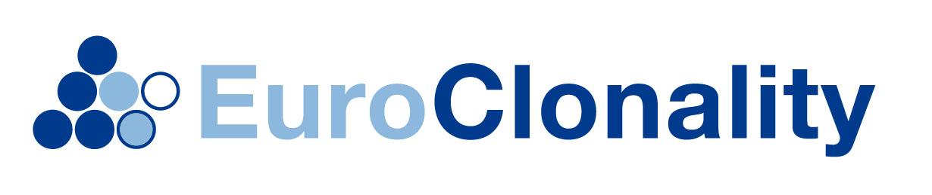  EuroClonality WORKSHOP: “Clonality assessment in Pathology”  February 15-17, 2016  Introduction  Clonality testing is at present an established tool in the diagnosis of malignant lymphomas. Between 5-15% of samples submitted to pathology laboratories which are suspected to be malignant lymphomas can benefit from clonality testing, provided that this is performed in laboratories with sufficient expertise. With the introduction of a new and complete set of primer sets for the full program of clonality testing by the Biomed-2 group in 2003, a major step in standardization and quality improvement was set. At the moment many laboratories throughout the world are introducing the technology, resulting in questions on pitfalls in technique and the interpretation of the results.  EuroClonality/BIOMED2 workshops  Therefore, the EuroClonality/Biomed-2 consortium decided to organize annual workshops for laboratories that have introduced clonality testing using the new Biomed-2 primers sets in order to further improve the quality and reliability of the technique in routine practice. Since the vision of the EuroClonality/Biomed-2 consortium is that clonality testing can be performed only reliably when there is close interaction between the molecular biologist and the (hemato)pathologist these workshops are organized for such partners.  The workshops are for a maximum number of 16 persons and uses cases from the Nijmegen group as well as cases from the participants on a hands-on basis, using multiheaded microscopy for pathology evaluation and raw data from clonality tests for interpretation.  We therefore invite persons to the workshop:  - who have started to use the Biomed-2 PCR technique  - who are able to bring cases for evaluation during the workshop  - who participate as combination of pathology and molecular biology: 2 persons per institute will be accepted for the workshop.  Participation  The registration fee for participation in the workshop is € 200. The registration form, including personal details and description of the cases to be presented, should be received by the Workshop Secretariat (workshop@euroclonality.org) no later than November 27, 2015. The registrants will be informed about the acceptance for the workshop no later than December 18, 2015. Information on the program, travel to Nijmegen and accomodation fees will be provided upon acceptance of the registrants.  With this background, we are convinced that the workshops are a very fruitful experience that will lead to improved diagnosis of malignant lymphomas and thereby better care for our patients.  On behalf of the EuroClonality/Biomed-2 consortium on Clonality testing,  Patricia Groenen, Han van Krieken and Ton Langerak  contact: workshop@euroclonality.org  www.EuroClonality.org | Workshop 2015  